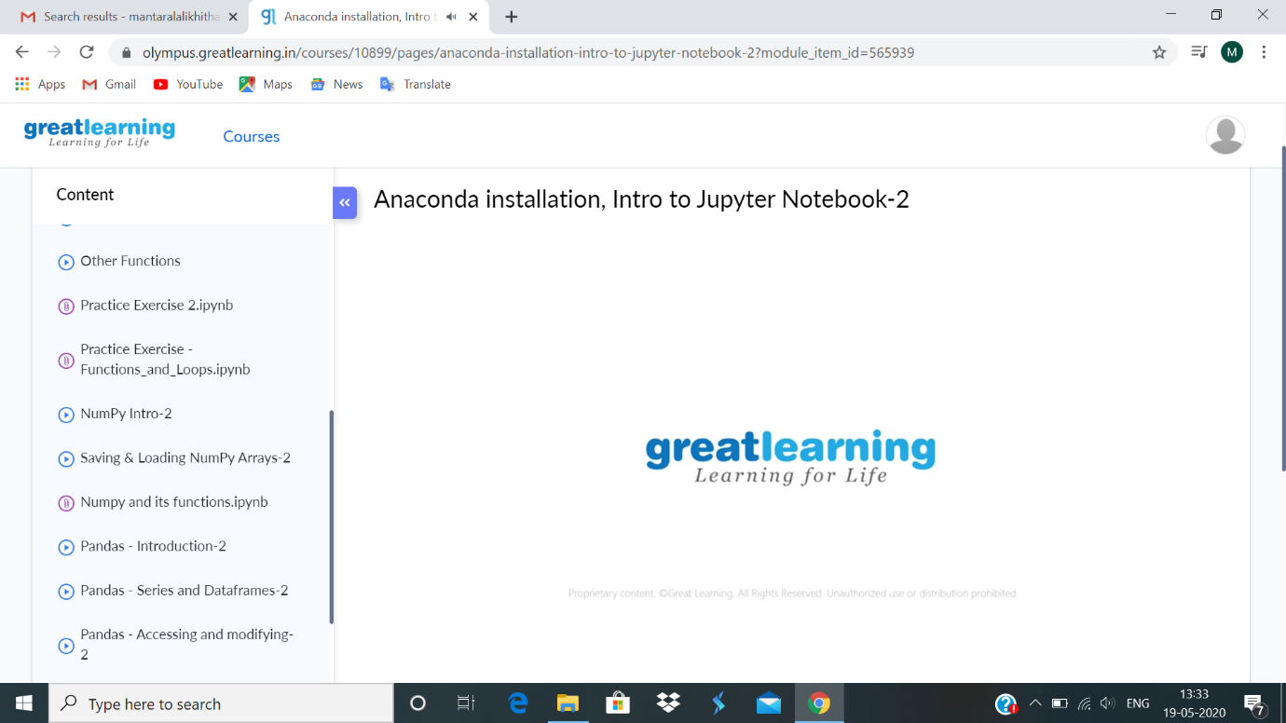

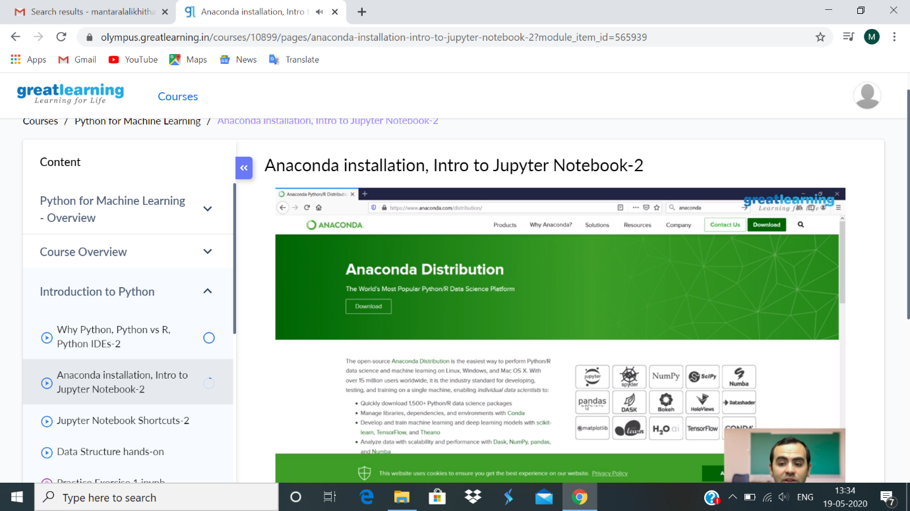

Installation of Anaconda, which is most popular python data science platform. There are different IDEs in anaconda like jupyter, spyder, panda etc. In anaconda prompt saw come list like panda etc. installed numpy through anaconda prompt. Learnt how to create jupyter notebook and and run some simple code in the cell.